Visiting a War Grave Cemetery in the Netherlands
Robert Hopkins Thomson

In 1939 – World War 2 began and brought about many changes. My father was a member of the local Home Guard until he was “called up” in 1943 and was enlisted in the Royal Artillery Regiment. He was first posted to Aldershot, then to Southborough near Tonbridge Wells, Kent.
In April 1944 D-Day was imminent and my mother was determined to see my father before he was shipped overseas. (It seemed inevitable that this would happen any time). My father somehow managed to get a two-day pass and arranged a place nearby for my mother to stay. How she managed to make this journey from Greenhill during the war when London was in the middle of constant bombing is beyond my understanding and my grandmother was not happy about this decision, especially as she was taking 3-year-old Robert and me (age10) with her. I do not know (or remember) how we got there and back. What I do remember is that a friend was working in London at that time met us at Euston Station. I have no knowledge as to how we got to Kent, but I do remember Dad coming into the house where we were staying. We obviously spent the night there; Dad’s leave from camp was only on a 24- or 48-hour pass. This was the last time that we saw him. We knew that he went overseas as we did have some mail and know that he went through France and Belgium to Holland.

He was killed on the 12th of October 1944 near the small town of Grave near Arnhem. A simple service was held at the graveside by the chaplain. He now lies in Uden War Cemetery in Holland one of the smaller Cemeteries in Northwest Europe.
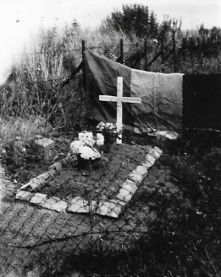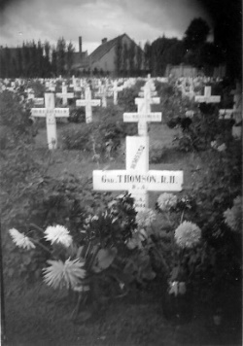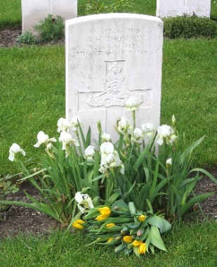
Original resting place Now in Uden Cemetery
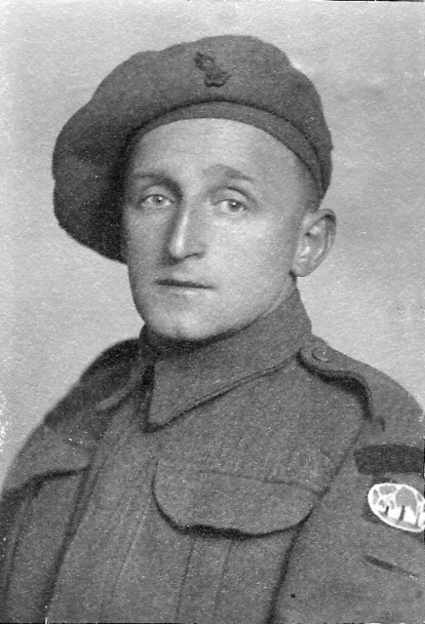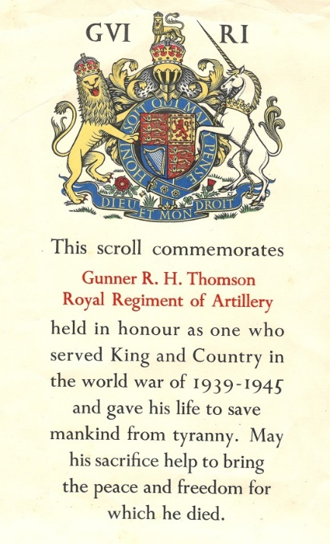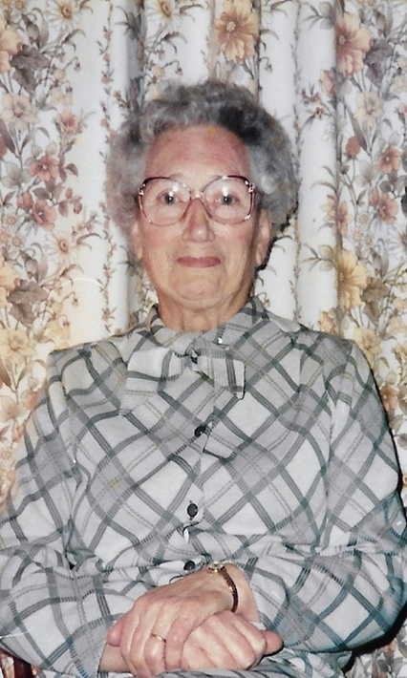
Robert Hopkins Thomson Margaret Thomson
Netherlands War Graves Committee (NWGC)

In 1947 my mother contacted the War Graves Committee (WGC) for information on making a visit to the War Cemetery at Uden. A reply came from the Netherlands War Grave Committee (NWGC). The reply said that she would hear from a Dutch family who had taken an interest in my father’s grave, and this was followed by a letter from the Dutch Family. The letter was written in their language but fortunately someone was able to translate it for us. This would be the family we would stay with when we visited the following year.
A quote from the correspondence received from the NWGC was: “The Netherlands population have made themselves responsible towards the dead of the second World War now resting in their soil. From this responsibility they cannot and will not withdraw”.
She was also informed that the plain wooden crosses that were originally placed on the graves would in time be replaced by headstones and we would have a choice of inscription to be put on the headstone.

The first visit to the cemetery was in late summer 1947 when we finally got the documents and travel arrangements for the journey to Holland. This part was organised by the British Legion. We went by ferry from Harwich to the Hook of Holland and then by rail and bus to Uden, a small town in a rural area of Holland. We were met and taken to the Dutch Family home for our short stay.
They were a lovely family so welcoming and pleased to do this for us. They had a son and daughter. The son told us how he had been taken out of school to work in a factory for the Germans. Words cannot express how awful life must have been for the Dutch people during the occupation. There were many stories to tell.

The Family gave us a large bunch of Chrysanthemums for the grave. The Cemetery was only a short walk away. We laid the flowers on the grave and took a few photographs. We then had a walk round the village before going back to the house.

The Dutch people and future generations have never forgotten the Allies who liberated the country and have made the 5th of June “Liberation Day” a National Holiday. That was our first visit to Uden, but not the last for either of us.

Subsequent Visits to Uden War Cemetery
1966: - On this visit Mum and I were on a coach tour and one of the stops was in Amsterdam. We were able to visit Uden on a full free day there. We went by train and bus. Uden had changed a lot since our last visit. After our visit to the cemetery, we did not have much time in Uden as the bus service back to the train station was limited. But I do remember Mum wanted a ‘souvenir’ to take home. She managed to find a little vase with Uden on it and I still have it!

1985: - By this time the Royal British Legion were organising pilgrimages to the war graves all over Europe. Mother and Aunt Annie (Thomson) made this visit with a British Legion Pilgrimage. These pilgrimages were partly funded by the government who contributed 90% of the cost and the participant’s making up the remaining 10%. There were 47 in the group from all over England and Scotland visiting cemeteries in the area around Arnhem.
They had an overnight stay in London.
Day 1:- They made their way to Dover for the ferry to Calais. Lunch was served on board. They then travelled through France and Belgium to Holland with a stop before reaching Nijmegen for the 3-night stay in the hotel.
Day 2:- Transport was provided to take groups to the cemeteries they were to visit. My mother and aunt Annie were taken to Uden by private car as they were the only two going to Uden war cemetery. After lunch there was time for shopping, then back to the hotel for dinner.
On day 3: - A service of remembrance was held at Oosterbeek (the large cemetery near Arnhem) then lunch at the hotel. There was a farewell dinner in the evening, and an early departure the next morning, for the journey home.

1991: - I was in Holland on holiday with my cousin Rea staying at Valkenburg. I decided to take a day to go to the cemetery and set out reasonably confident about the train and bus journey. When I arrived in Uden that day – all had changed! It was now a busy big town with a shopping centre. I had not a clue where I was. After a few enquiries I was directed to a cemetery, but it was not the Uden War cemetery.
There were 2 groundsmen working in the cemetery, so I went and asked for directions from there to the war cemetery. The younger of the two spoke English well and said that it was not far away and that he would take me there. So, before I knew what I was doing I was in his van and on my way with great relief. I soon recognised where I was as we approached the Cemetery. He asked me if I was sure that I knew how to get back to the bus station before he left me. I assured him and thanked him for his kindness. He said he was pleased to be of assistance.
I had bought a plant rather than flowers earlier, took some photographs and just as it started to rain, I made my way back to the bus station and back to Valkenburg.

2005: - On this visit Bert and I went by Easy Jet to Amsterdam, and we stayed in accommodation close to the train station which turned out to be convenient for getting around. The booking clerk at the station was brilliant as she was able to provide the times, where to change trains including the arrival platforms and the bus to get to Uden and back. When we arrived at Uden I found the area had changed completely again compared to my previous visit. After getting our bearings we had some lunch and then to a florist for some flowers. We chose yellow tulips then made our way to the cemetery. Bert took some photographs.
There wasn’t anyone else around, except a gentleman who lived just across the road. He came out to speak to us, just wanted to know where we came from and whose grave we were visiting. He was very helpful though his English was not so good. He asked if we would be attending the annual Service of Remembrance being held in two weeks’ time. Had we known we would have
arranged our travel to coincide with the Remembrance.

Back in Amsterdam we found out that there was a Festival of Flower Floats in nearby Haarlem and on the Sunday these Floats would be on display in the town. That was a fantastic show and in lovely weather too. We also spent a whole day at Keukenhof gardens where all the bulb growers display thousands of bulbs.

2015: - Bert and I went on probably the last coach tour organised by Fitzcharles of Grangemouth, to Eindhoven. Again, we went to the cemetery, but this time Uden was much closer and easy to get to by bus from just outside the hotel. The tour included a trip to the town of Zundert where there was a parade of 19 giant floats made with flowers, mainly dahlias, commemorating the birth of Vincent Van Gogh.

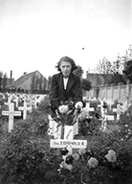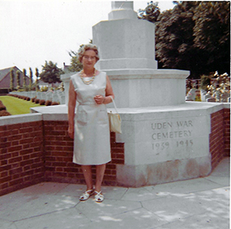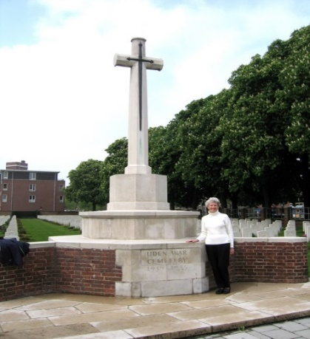
Me 1947 Mother 1996 Me 2005

War cemeteries are all kept in pristine condition. At each visit I have made they look exactly as before. Uden Cemetery lies in a quiet corner of which is now a busy town.

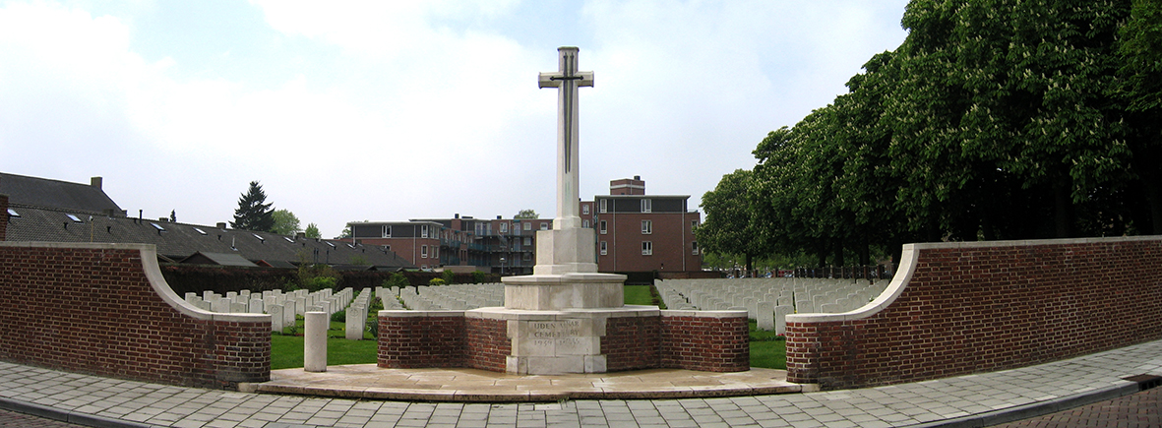
Entrance

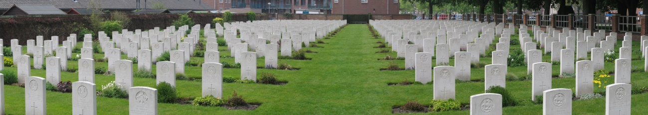

At the entrance to the cemetery there was a small seating area with a plaque mounted on the wall which said:
“The land on which this cemetery stands is a gift of the Dutch people for the perpetual resting place of the sailors, soldiers and airmen who are honoured here”

Mae Blackwell

